PREPARATION AND MAINTANENCE OF ZOHO BOOKS OF ACCOUNTS FOR FASHION HAVEN

(FASHION HAVEN-INDUSTRY)

Introduction:

1.1Overview:

Fashion haven,refers on Zoho books to manage customers buying ,profit on business of fashion haven .Managing the financial aspects of a fashion haven is crucial for its success. One essential tool in this endeavor is Zoho Books, a comprehensive accounting software. In this guide, we will delve into the preparation and maintenance of accounts using Zoho Books, helping fashion businesses maintain financial clarity and growth.

2.Purposes:

The purposes of using Zoho Books for fashion businesses are multifaceted. This software enables efficient financial management, ensuring.

Zoho Books helps maintain precise and up-to-date accounting records, preventing errors in financial reporting.

It simplifies tracking expenses, including purchases of fabrics, accessories, and other materials, enabling better cost control.

Businesses can create and send professional invoices to clients, facilitating prompt payments.

Zoho Books aids in tracking and managing inventory, critical for fashion businesses to ensure stock availability and avoid overstocking.

overall ,Zoho books serves as a versatile tools for fashion haven.

2.PROBLEM DEFINITION &DESIGN THINKING:

2.1 EMPATHY MAP:



2.2 IDEATION &BRAINSTROM MAP:

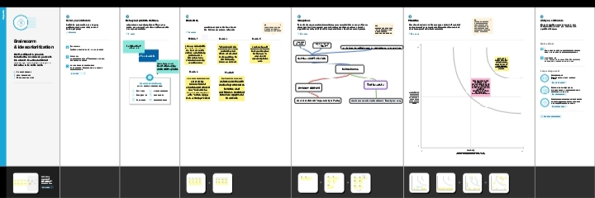

3.RESULT:

OUTPUT:

The output ofprofit and loses for keerthi zoho company from 01/04/2023 To 31/03/2024 with profit

Rs.235000

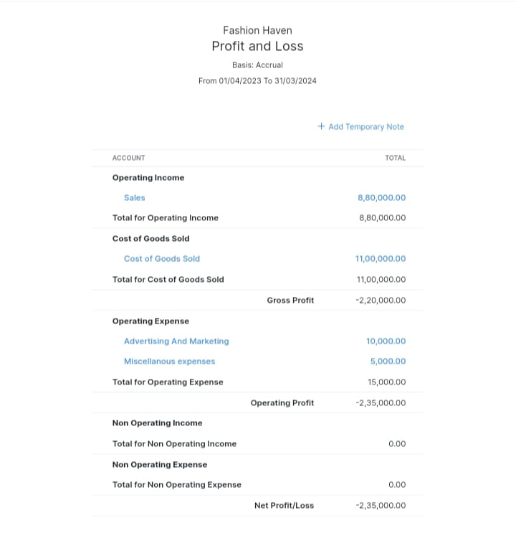

The balance sheet as on 31/03/2024 with the total assets and the total liabilities of rs.384000.

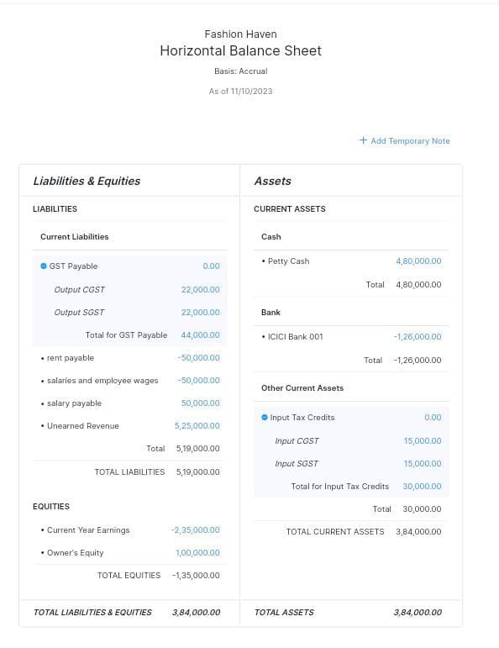

4.ADAVNTAGES &DISADVANTAGES:

: 1. \*User-Friendly Interface:\* Zoho Books offers an intuitive and user-friendly interface, making it accessible for users with varying levels of accounting knowledge.

2. \*Time Efficiency:\* Automation features help save time on repetitive tasks, such as invoicing and expense tracking, allowing fashion businesses to focus on core activities.

3. \*Accuracy:\* The software reduces the likelihood of manual errors in financial records, ensuring data accuracy.

4. \*Financial Insights:\* Zoho Books provides valuable financial insights through reports and analytics, aiding in informed decision-making.

5. \*Mobility:\* Accessible via mobile apps, it enables business owners and accountants to manage finances on the go.

6. \*Scalability:\* The software can grow with your fashion business, accommodating increased transactions and complexity.

7. \*Integration:\* Zoho Books seamlessly integrates with other Zoho applications and third-party tools, enhancing functionality.

Disadvantages of using Zoho Books:

1. \*Cost:\* While it offers various pricing tiers, Zoho Books is not entirely free, and some advanced features may require higher subscription levels, which could be a disadvantage for smaller businesses.

2. \*Learning Curve:\* Despite its user-friendly design, there may still be a learning curve for those who are new to accounting software.

3. \*Limited Advanced Features:\* For businesses with complex accounting needs, Zoho Books may have limitations compared to more advanced, dedicated accounting software.

4. \*Internet Dependency:\* It operates primarily online, so a stable internet connection is necessary for access, which might be a drawback in areas with unreliable connectivity.

5. \*Customization:\* While it's customizable to some extent, it may not fully cater to very unique or specialized accounting needs.

6. \*Data Security:\* Storing financial data in the cloud may raise concerns about data security, and businesses must ensure proper measures are in place.

5.APPLICATION:

Zoho Books finds applications in fashion businesses by simplifying financial tasks like invoicing, expense tracking, and inventory management. It generates insightful reports, facilitates tax compliance, and enables mobile accessibility, making it an essential tool for efficient financial management in the fashion industry.

6.CONCLUSION:

In conclusion, Zoho Books is a powerful and flexible accounting software that holds significant value for fashion businesses. It streamlines financial processes, ensures data accuracy, and provides insights critical for informed decision-making. While it has some limitations, its advantages, including ease of use, scalability, and mobility, make it a valuable asset in maintaining financial clarity and fostering the success of fashion havens.